Title of paper (use ‘Title’ style)
Author One1, Author Two2 and Author Three3 (initials and surnames only)
Note: Presenting author’s name should be underlined.
1.Position title, Organisation Name, City, Country. Email:
2.Position title, Organisation Name, City, Country. Email:
3.Position title, Organisation Name, City, Country. Email:
…etc

ABSTRACT (USE ‘heading 1’ STYLE)
300 words abstract here…(Use ‘Body Text’ style)
Note: Do not use extra returns between paragraphs, or double spaces between sentences.
Keywords: list keywords here (3–5 keywords)

INTRODUCTION (USE ‘heading 1’ STYLE)
Text here… (Use ‘Body Text’ style)
Note: The paper length is limited to 8 pages in total, including references, figures, and tables. do not insert a page break after the abstract; the Introduction should continue in the same page.
Figures should be placed within the body of the paper soon after being mentioned. Number of Figures should less than 6.
Crop images to best reflect subject matter.
Insert image using ‘Image style’
For example, a figure can be cited as follows: “As shown in Figure 1, the trend indicates …”. Ensure all figures are referenced in the text.
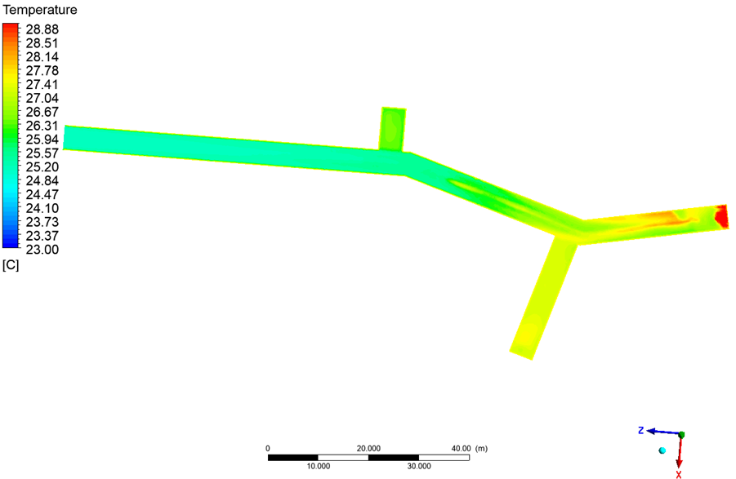
FIG 1 – Caption … (Use ‘Figure Caption’ style)

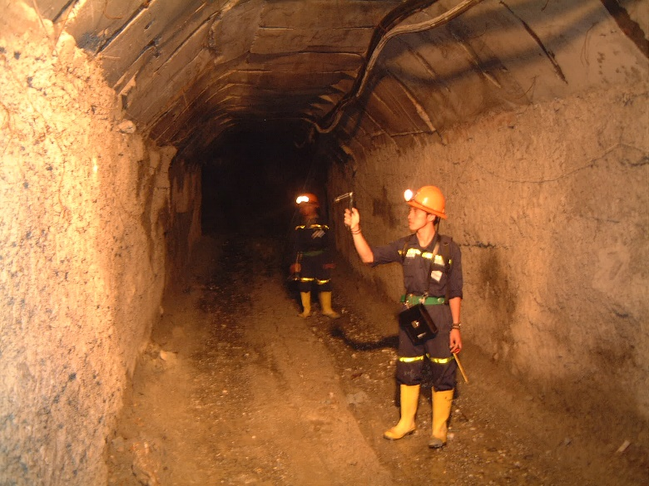
FIG 2 – Caption … (Use ‘Figure Caption’ style)

Tables should be placed within the body of the paper soon after being mentioned.
TABLE 1 – Caption … (Use ‘Table Caption’ style)
Column 1 (Use ‘Table text header row’ style) | Column 2 | Column 3
X (Use ‘Table text’ style’) | 10 | 50
Y | 20 | 55
Z | 30 | 62
X | 40 | 50
Y | 60 | 50
Z | 20 | 35
x | 15 | 10

Next heading Level 1 (USE ‘heading 1’ STYLE)
Text here… (Use ‘Body Text’ style)
Other styles available to use:
- Bullets level 1
- Bullets level 2
- Numbers 1
Quotes

Heading level 2 (Use ‘Heading 2’ style)
Text here… (Use ‘Body Text’ style)

Heading level 3 (Use ‘Heading 3’ style)
Text here… (Use ‘Body Text’ style)

CONCLUSIONS (USE ‘heading 1’ STYLE)
Text here… (Use ‘Body Text’ style)

ACKNOWLEDGEMENTS (USE ‘heading 1’ STYLE)
Text here… (Use ‘Body Text’ style)
Note: please acknowledge collaborators here or anyone who has helped with the paper. It may also be appropriate to acknowledge company approval to publish.

REFERENCES (USE ‘heading 1’ STYLE)
List references here (Use ‘Reference List’ style)
Example of reference list formatting:
Smith, J., & Brown, T. (2020). Title of the article. Journal Name, 10(2), 123–134.
Doe, A. (2018). Book Title. Publisher.

Example of in-text referencing: (Smith & Brown, 2020), or “as stated by Smith and Brown (2020)”.

Note: List references alphabetically by author surname. Do not use a numbered list. All references must be linked to the text.

